EasyPay

**General Guidelines for Easy Pay**

* With this feature we are giving our guests the flexibility to schedule their final payment via an installment plan. The number of installments that a guest can select will depend upon how far is final payment date for his booking.
* As of now we are offering only 3 month plan, however we will be adding 6 month and 12 month plans in near future.
* The installment due date will always be 30 days away from the day guest opted for the plan. There is one exception to this rule- in case guest opted the plan on 29, 30 or 31 of any month; they will always be charged their installment on 28 of the following months otherwise they will be charged on the same date of next month.
* In case booking undergo change sailing or change rate code which has its own payment guidelines, system should drop the plan giving an advisory to the guest that their plan has been dropped due to the changes done on the booking.
* This feature is not applicable for Group Cabins.
* This feature is only available for Credit card payments.

**Easy Pay Availability**

## Before Booking Creation:

* Invoice pricing program (Message Id: CCINVPR1) has been modified (new segments have been added in response) in order to identify what installments plans are available for a booking during the new booking flow.
* There is no change in the Invoice Pricing Request to get this information in the response. If the booking is eligible for Easy Pay, system will return this information in the response.
* Below is the sample how this information will be returned.

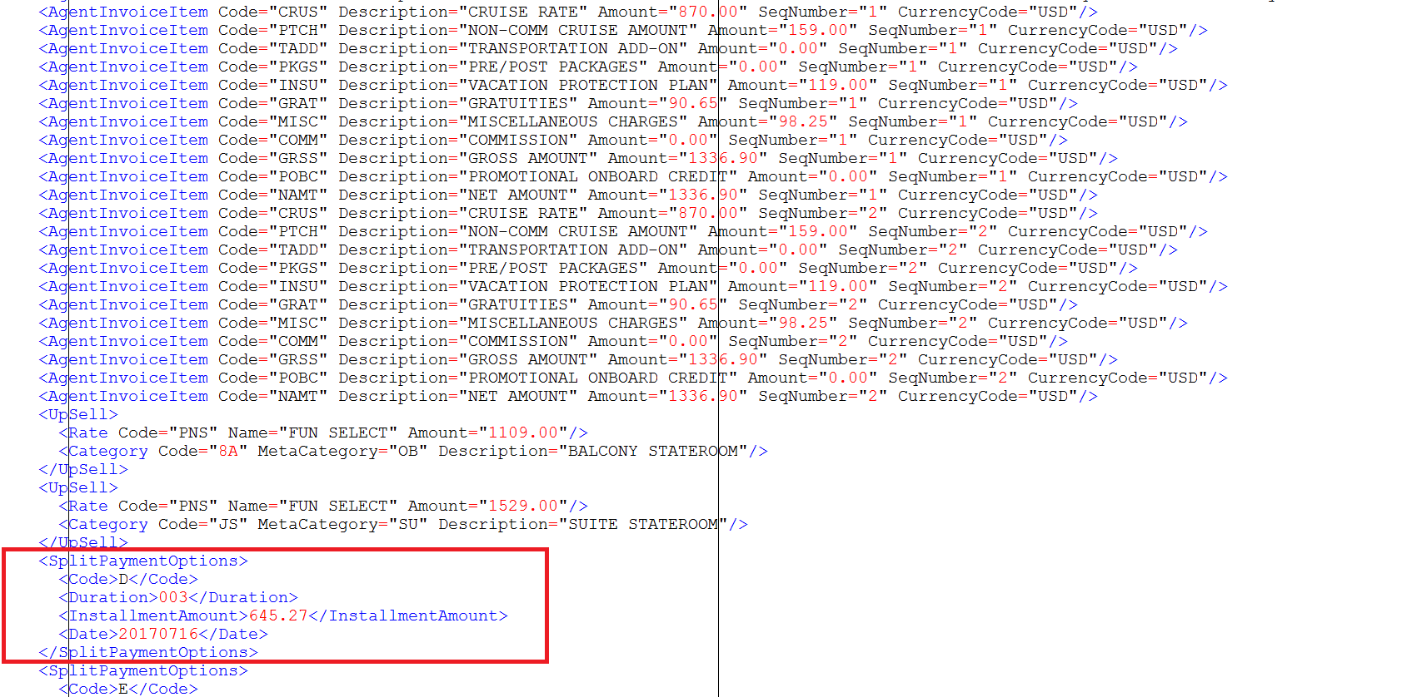

* There will a new segment in the response “SplitPaymentOptions” (segment name: INVSPY) as shown in the above screenshot which will advise what installment plans are available for your booking.
* The new segment will have following 4 fields:
  + Installment Code: Each installment has been tied to a code which needs to be sent when requesting for that plan in the create revise call.
  + Installment Duration: This field will advise what the duration of the plan is like 3 months, 6 months etc.
  + Installment Amount: It will advise how much will be amount for each installment if you select that plan.
  + First Installment Date: This date will advise when your first installment will be deducted if you select this plan.
* If there are multiple installment plans available, you will see multiple occurrences of this segment with different data in above mentioned fields.

## Post Booking Creation

* Booking Display call (Message Id: CCBKDSP1) has been modified (new segments have been added in response) in order to identify what installments plans are available for a booking.
* There is no change in the Booking Display Request to get this information in the response. If the booking is eligible for Easy Pay, system will return this information in the response.
* Below is the sample how this information will be returned.
* There will a new segment in the response “SplitPaymentOptions” (segment name: BKSPAY) as shown in the below screenshot which will advise what installment plans are available for your booking.
* Similar to Invoice pricing it will have the same fields with the same definitions.
* 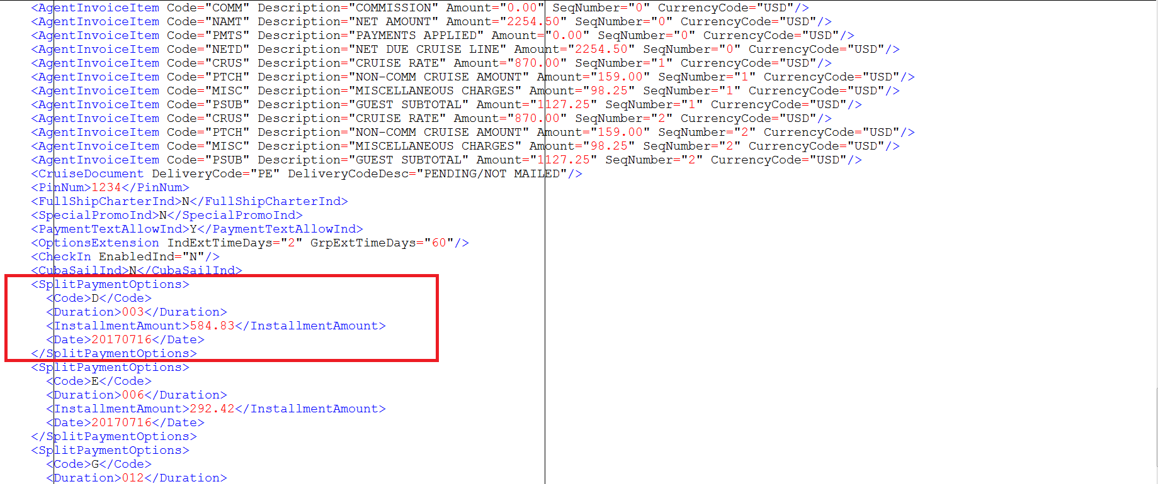

**Opting for Easy Pay**

* In order to opt for Easy Pay, we need to use the Create revise request.
* If you are requesting for this feature while creating the new booking, we should be using the message id CCNEWBK1 and while requesting it post booking we should be using the message id CCCHGBK1
* In the payment segment BKPUCC for Create Revise request, there is an existing field Auto-Payment-Ind (BKPUCC-AUTO-PAYMENT-IND) which we have reused for opting Easy Pay.
* You need to pass the installment code value as returned in Invoice Pricing response (pre-booking) or booking display response (post booking) in the field Auto-Payment-Ind to opt for a specific plan along with the other required details and credit card information.
* For e.g. as shown in the above screenshots, installment code D is for a 3 month plan, so you need to pass ‘D’ in this field along with the credit card details that you want to be used for making the payment and scheduling the installments.
* If the payment is successful, you will receive an advisory that Easy Request has been completed.

**Getting Easy Pay Installment Summary**

* Once your Easy Pay Request has been confirmed, the booking display response will give you all the information related to your future installment dates, details of card currently enrolled in Easy Pay and whatever installments already processed.
* Below is the sample how the installment summary will be returned once Easy Pay is opted.

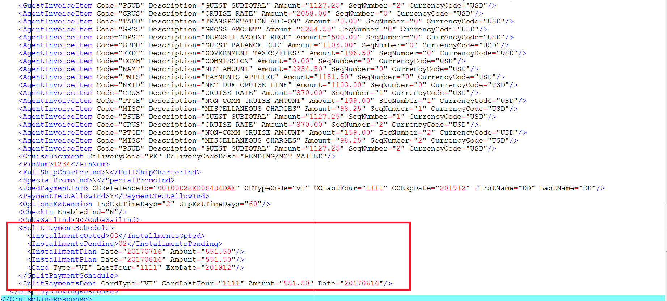

* Below is the summary of changes done to the booking display response :
  + New fields have been added in the existing BKDSP2 segment for:
    - InstallmentsOpted: How many installments you originally opted
    - InstallmentsPending: How may installments are currently pending
    - CardType: Credit card type currently enrolled in Easy Pay (VISA, MC etc)
    - LastFour: Last 4 digits of the card currently enrolled in Easy Pay
    - ExpDate: Expiration Date of the card currently enrolled in Easy Pay
  + New segment BKPLAN has been added with the following fields to identify future installments:
    - Installment Date: What are your installment dates
    - Installment Amount: What is the amount for each installment
  + New segment BKPPAY has been added with the following fields to identify what installments have already been processed:
    - Card Type: Type of card used for that installment
    - CardlastFour: Last 4 digits of the card for that installment
    - CardAmount: Installment amount
    - Date: Date on which the installment was processed.

**Cancelling the Easy Pay**

* You can opt out from the Easy Pay program before your last installment date.
* In order to opt out for Easy Pay feature, you need to use the create revise request with message id CCCHGBK1 and pass a value ‘C’ in the same field Auto-Payment-Ind (BKPUCC-AUTO-PAYMENT-IND).
* If the request is successful, you will see an advisory in the response that Easy Pay was cancelled successfully.

**Changing the Card Enrolled in Easy Pay**

* If for some reason, you need to change the card that was enrolled in Easy Pay earlier, you can use achieve the same by using the create revise request with message id CCCHGBK1 and pass a value ‘X’ in the same field Auto-Payment-Ind (BKPUCC-AUTO-PAYMENT-IND) along with the new credit card details and at least a dollar amount so that the new card can be authenticated.
* If the new card is approved, you will see a confirmation in the response that card details have been updated successfully and for the next installment, system will charge your new card.